**Pingxi Sky Lantern Festival - Taipei**

Sparkling festival of sky lanterns in Binh Khe, Taipei

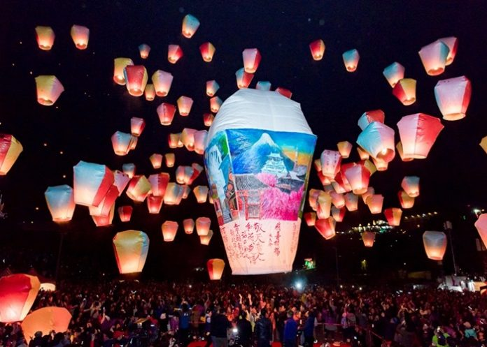

Referring to the sky lantern festivals, it would be remiss to ignore the Binh Khe sky lantern festival - Pingxi Sky Lantern Festival - the biggest, brightest, most spectacular and most anticipated festival in Taiwan. This is the only festival in all of Taipei's traditional festivals that has been kept almost intact until now and grows bigger and bigger.

Pingxi Sky Lantern Festival - Taipei

1. The birth of Binh Khe sky lantern festival

This tradition comes from an old story. Pingxi (Pingxi) is a remote mountainous area in Taipei. During the reign of Emperor Daoguang of Ching Dynasty (1820-1850), residents from Fujian province were often robbed or murdered. So, after the harvest season, the villagers had to hide in the high mountains. When the robbers left on January 15, someone released a sky lantern, signaling safety and calling people home.

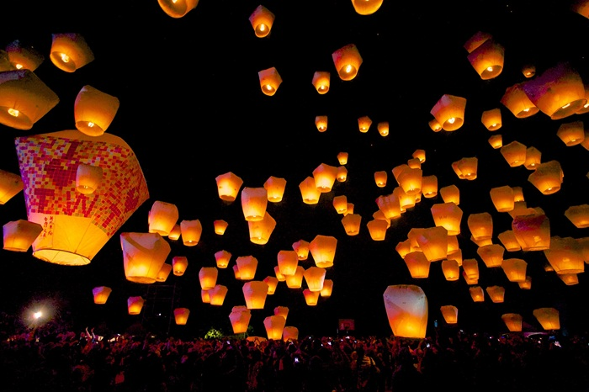

Since then, on this day, people still keep the custom of releasing sky lanterns to signal peace. By the end of the 20th century, when the traditional values of the national culture were more focused, the sky lantern festival became a big event.

2. Time and place of Binh Khe sky lantern festival

Binh Khe sky lantern festival is usually held annually on the 15th day of the first lunar month. The festival lasts about 1 week, at many different locations where sky lanterns are released. These locations are all approved and announced by the Taipei city government in advance. Each location has its own operating hours and regulations.

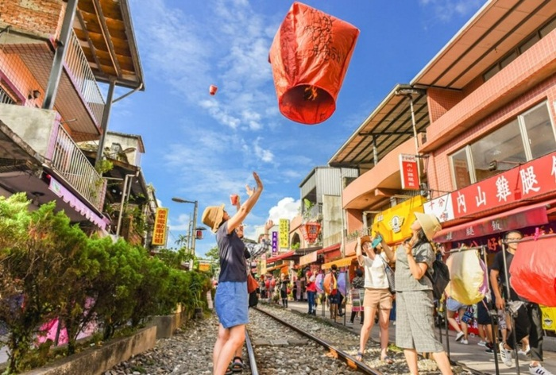

Main venues: Jingtong Primary School and Pingxi Middle School. The closing ceremony and also the busiest holiday was held at Shifen Sky Lantern Square, Pingxi District, New Taipei City.

Organizer: New Taipei City Government (New Taipei)

Hours of operation: 18:00 to 21:00

3. Unique features in Binh Khe sky lantern festival

The lights at the Binh Khe sky lantern festival are provided free of charge by sponsoring organizations. For the first 3 days, there are three sessions of light dropping each day. Sessions are held at three different locations. Visitors can also release their own lights at designated locations and times (usually every 20 minutes).

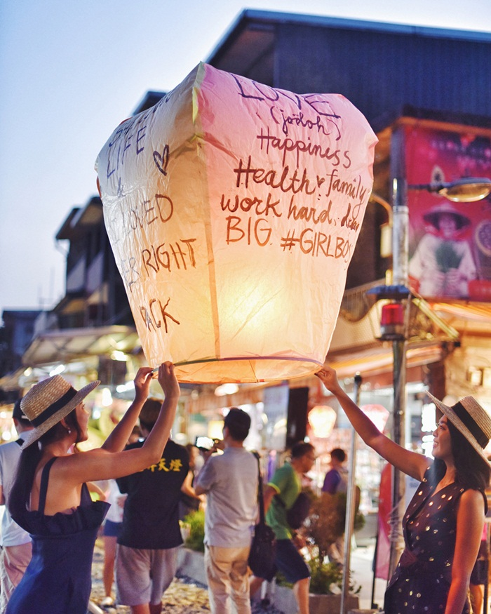

The lantern is shaped like a basket, made of cotton paper. The lamp frame is made of bamboo slats. The wick is made of cotton, impregnated with kerosene. When the wick is ignited, the air inside heats up, and the lamp rises. On the body of the lamp, you will write your wishes and pray for your wishes to reach the gods.

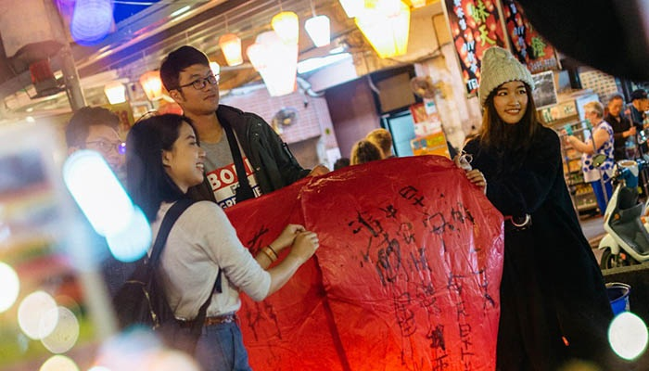

If you are lucky enough to attend the festival at the best time of the light-dropping session, you will admire a brilliant fanciful night sky with thousands of lights flying up. You will feel like you are lost in a fairy tale world. There is a shimmering light with many dreams and hopes. You will enjoy a moment of true relaxation. All troubles seem to fly away with each lamp.

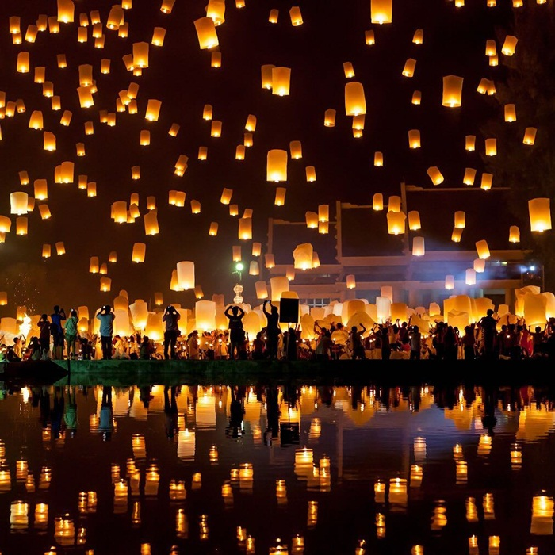

At the time of the festival, all roads to the area are closed. Fire trucks will be on hand to deal with any incidents. Cleaning units are also always on standby.

4. The meaning of Binh Khe sky lantern festival

The Binh Khe sky lantern festival as well as in Taiwan in general has many special meanings. Taiwanese people believe that, when they write their wishes on a lamp and release it into the sky, God will read those wishes.

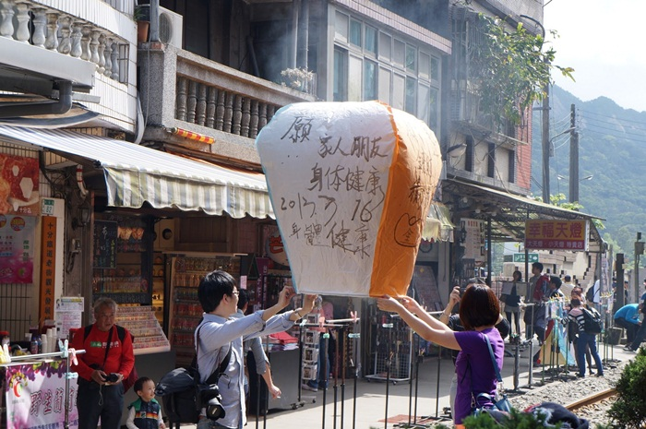

Besides, the release of lights also shows the desire to reach high, wishing for luck and prosperity to come to everyone and every home.

5. One and note when participating in Binh Khe sky lantern festival

On these days, people come to the festival site very crowded. Therefore, to avoid crowds, traffic jams, and hard travel, you should go early. You can rent a car in groups for convenience.

Before releasing the lights, you can visit the ancient villages of Shifen and Jiufen. Jiufen Village is the village in the animated movie 'Spirited Away' by famous director Hayao Miyazaki.

Don't forget to bring your camera, camcorder to record the best images in the festival, and to have a picture of millions of likes to post on facebook!

Prepare your wishes in advance and write your wishes on the lantern.

Gently pull open the lantern so that all four upper corners are completely open. You should have someone hold the lantern at the bottom to ensure enough hot air enters the lamp.

Inspect the lantern for any external damage. Lanterns cannot fly if hot air is exposed.

After releasing the lamp, do not throw the lamp cover indiscriminately.

Pingxi Sky Lantern Festival is really worth experiencing when in Taiwan travel. If you have the opportunity to visit Taipei around January, don't miss the opportunity to attend this wonderful festival!